Finding topic and dataset.

I’d like to look into Healthcare.

Looking into healthdata.gov

<http://www.healthdata.gov/dataset/medicare-medicaid-enrollee-profiles-state-and-national>

Q: better understand demographics?

Managed to look at MIMIC site but data acquisition/selection seems not particularly easy.

For example:

Can patient healthcare records predict the likelihood of mortality in an emergency room visit?

<https://mimic.physionet.org/>

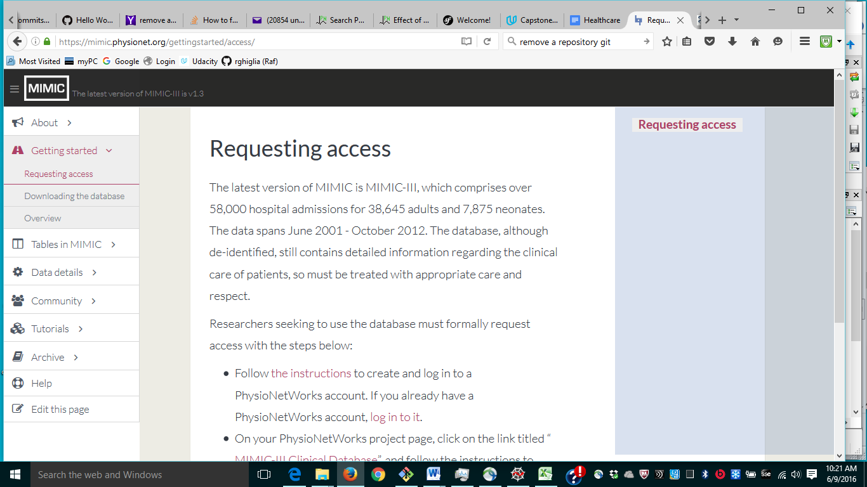

<https://physionet.org/physiobank/database/mimic3cdb/>

There is a lot of data and tables. I think I need to spend some time in understanding the info.

The question is interesting.

Also interesting question:

• During labor, when should natural labor be interrupted for a C-section to maximize the health of both the mother and the child? (Answerable with [MIMIC](https://www.google.com/url?q=https://mimic.physionet.org/&sa=D&ust=1465482380485000&usg=AFQjCNE3fvH5cERCuH3Rg5ahpamfxWqglQ))

I am waiting to get access (I think).

Alternatively, I can brush up the material from ODSC conference.

I also checked other 2 topics: deep learning and investment. Both have courses. I need to check them out. There is also a course in healthcare.

Yelp:

<https://www.yelp.com/dataset_challenge>

For Android and Google fit you can record your own data:

<https://developers.google.com/fit/android/record>

<http://www.cdc.gov/nchs/tutorials/PhysicalActivity/SurveyOrientation/Navigate/>